Homework 5

Transfer Function and Coherence Function Estimation

**Name:** Jinhan Zhang

**Class:** ECE 251A Digital Signal Processing I

**Date:** 02/21/2017

**Transfer Function and Coherence Function Estimation**

**·Objective**

Use Matlab to do transfer function and coherence function estimation, and also analyze the confidence interval of the estimations.

**·Background**

The transfer function tells us how one signal transfer into another one, which means the relationship between two signals. The coherence function talks about the degree of causality between two signals. They are important for us to analyze the system characteristics, so in this homework we are going to do transfer function estimation and coherence function estimation and also analyze their confidence intervals.

·**Approach**

Firstly, we will build a system as system diagram below.

**w1(n)**

**Low pass filter**

**h(n)**

**y(n)**

**w2(n)**

**r(n)**

Where wl(n) is a Gaussian random sequence with zero-mean and variance equals to 1, w2(n) is a Gaussian random sequence with zero-mean and variance equals to , and h(n) =

, n = 0,..., 7.

Secondly, we will generate transfer function plots of the low-pass filter h(n), including dB magnitude, linear magnitude and phase.

Thirdly, we estimate the dB and linear auto-power spectrum , , , respectively. And also do cross-power spectral estimation , .

Finally, we estimate the transfer function , and magnitude-squared coherence function estimates , , then analyze their confidence intervals using the table provided.

·**Results**

Fig. 1 shows the dB magnitude of the transfer function h(n), we can see that at 0 cycle/sample H(f) has 0 dB magnitude because we have normalized our low-pass filter and the first side-lobe is about 13dB below main lobe. Fig. 2 is the linear magnitude of H(f) and Fig. 3 is the phase of H(f).

Fig. 4 shows the dB power spectrum estimation of , we can see that fluctuates around 0dB, and Fig. 5 is the linear power spectrum estimation of . Fig. 6 shows the dB power spectrum estimation of , similarly it fluctuates around dB, which is because the variance of is , and Fig. 7 is its corresponding linear power spectrum estimation. Fig. 8 shows the dB power spectrum estimation of the signal after low pass filter, we can see its shape is similar to Fig. 1. Fig. 9 is the corresponding linear power spectrum estimation. Fig. 10 shows the dB power spectrum estimation of the final signal r(n), we can see it’s much more distorted, and Fig. 11 is the corresponding linear power spectrum estimation. All the auto-power spectrum estimations are computed by ‘pwelch’ function with 50% overlap and 128-point hamming window.

Fig. 12 shows the cross-power spectral estimation computed by . We can see that the plot is similar to the dB magnitude of, but with some distortion. Fig. 13 is the corresponding linear magnitude, while Fig. 14 is the corresponding phase plot which is also similar to the phase of in Fig. 3. Fig. 15 is the cross-power spectral estimation computed by . The plot is much more distorted compared with Fig. 12 due to the introduction of w2(n). Fig. 16 is the corresponding linear magnitude, while Fig. 17 is the corresponding phase plot but this time with much more phase distortion compared with Fig. 14. All the cross-power spectrum estimations are computed by ‘cpsd’ function with 50% overlap and 128-point hamming window.

Fig. 18 is the estimation of transfer function between w1(n) and y(n). We can see from the plot that the estimation is good compared with the dB magnitude of in Fig. 1. And the first side-lobe of the estimation is -13.23 dB, which matches our theoretical value. Fig. 19 and 20 are its linear magnitude and phase respectively which are similar to Fig. 2 and Fig. 3 respectively. Fig. 21 is the estimation of transfer function between w1(n) and r(n). We can see that the plot is like to be distorted, this is because that we introduce the w2(n) to y(n) then the transfer function should be changed when compared with y(n). Fig. 22 and 23 are its linear magnitude and phase respectively which is also somehow distorted by w2(n). Then we analyze the confidence of the transfer function as Table 1&2 below.

Table.1 90% confidence interval of

|  |  |  |  |  |  |
| --- | --- | --- | --- | --- | --- |
|  |  |  | Phase(rad) | confidence interval | Phase(rad) confidence interval |
| 0 | 0.9904 | -0.3532 | 0 | Tighter than [-0.3532-1.3, -0.3532+1.1] | Tighter than [-0.1396, 0.1396] |
| 0.1875 | 0.9902 | -13.23 | -0.9977 | Tighter than [-13.23-1.3, -13.23+1.1] | Tighter than [-0.9977-0.1396, -0.9977+0.1396] |
| 0.3125 | 0.9932 | -16.34 | -0.5986 | Tighter than [-16.34-1.3, -16.34+1.1] | Tighter than [-0.5986-0.1396, -0.5986+0.1396] |

For all 3 frequencies is over 0.9 which is not available in the table provided, so the confidence interval for |H| will be smaller than [-1.3, +1.1] in the table and the confidence interval for phase (°) will be smaller than [-8, +8] (I have converted to radian in Table 1 and Table 2 below).

Table.2 90% confidence interval of

|  |  |  |  |  |  |
| --- | --- | --- | --- | --- | --- |
|  |  |  | Phase(rad) | confidence interval | Phase(rad) confidence interval |
| 0 | 0.968 | -0.4172 | -6.283 | Tighter than [-0.4172-1.3, -0.4172+1.1] | Tighter than [-6.283-0.1396, -6.283+0.1396] |
| 0.1875 | 0.5984 | -14.84 | -13.56 | [-14.84-3.5, -14.84+2.5] | [-13.56-0.3316, -13.56+0.3316] |
| 0.3125 | 0.466 | -15.8 | -13.36 | [-15.8-4.5, -15.8+3.0] | [-13.36-0.4189, -13.36+0.4189] |

For f = 0 cycle/sample, is over 0.9 which is not available in the table provided, so the confidence interval for |H| will be smaller than [-1.3, +1.1] in the table and the confidence interval for phase (°) will be smaller than [-8, +8]. For f = 0.1875 cycle/sample, is 0.5984. So I choose to use the data for which is closest to 0.5984. So the confidence interval for |H| will be smaller than [-3.5, +2.5] in the table and the confidence interval for phase (°) will be smaller than [-19, +19]. For f = 0.3125 cycle/sample, is 0.466. So I choose to use the data for , which is closest to 0.5984. So the confidence interval for |H| will be smaller than [-4.5, +3.0] in the table and the confidence interval for phase (°) will be smaller than [-24, +24]. We can see from Table 2 that the confidence intervals become larger and our estimations become more unreliable due to w2(n).

Fig. 24 is the magnitude-squared coherence function estimation , we can see that at most frequencies, has a high value near 1. This is due to that from w1(n) to y(n) the input only passes through a low pass filter, so the causality at most of frequencies between w1(n) and y(n) is high. Fig. 25 is the magnitude-squared coherence function estimation , we can see that at most frequencies, are much lower than . This is due to that from w1(n) to r(n) the input passes through a low pass filter and then get an additive noise w2(n), so the causality at most of frequencies will be much lower than .

Table.3 90% confidence interval of

|  |  |  |
| --- | --- | --- |
|  |  | confidence interval |
| 0 | 0.9904 | Higher than 0.9, it would tighter than the interval for 0.9 |
| 0.1875 | 0.9902 | Higher than 0.9, it would tighter than the interval for 0.9 |
| 0.3125 | 0.9932 | Higher than 0.9, it would tighter than the interval for 0.9 |

For all 3 frequencies is over 0.9 which is not available in the table provided, so the confidence interval for |H| will be tighter than the interval for 0.9.

Table.4 90% confidence interval of

|  |  |  |
| --- | --- | --- |
|  |  | confidence interval |
| 0 | 0.968 | Higher than 0.9, it would tighter than the interval for 0.9 |
| 0.1875 | 0.5984 | [0.36, 0.74] |
| 0.3125 | 0.466 | [0.25, 0.67] |

For f = 0 cycle/sample, is over 0.9 which is not available in the table provided, so the confidence interval would tighter than the interval for 0.9. For f = 0.1875 cycle/sample, is 0.5984. So I choose to use the data for which is closest to 0.5984. So the confidence interval would be [0.36, 0.74]. For f = 0.3125 cycle/sample, is 0.466. So I choose to use the data for , which is closest to 0.5984. So the confidence interval would be [0.25, 0.67]. All these data in the table is chosen as number of averaging = 16, although we are using 15 averaging.

**·Summary**

Since correlation function is frequency independent, when we get correlation which is not big or small we actually can’t get much information. So we need a way to estimate frequency-dependently. In this assignment, we do transfer function estimation and coherence estimation in a simple model. We can see that before we add w2(n) onto the signal, the causality between input and output is high at most of the frequencies and the estimation is relatively good. After we put w2(n) into the signal, the causality decreases a lot at most of frequencies. And the confidence interval becomes very large in this case, thus our estimation becomes much more unreliable.

**·Plots**

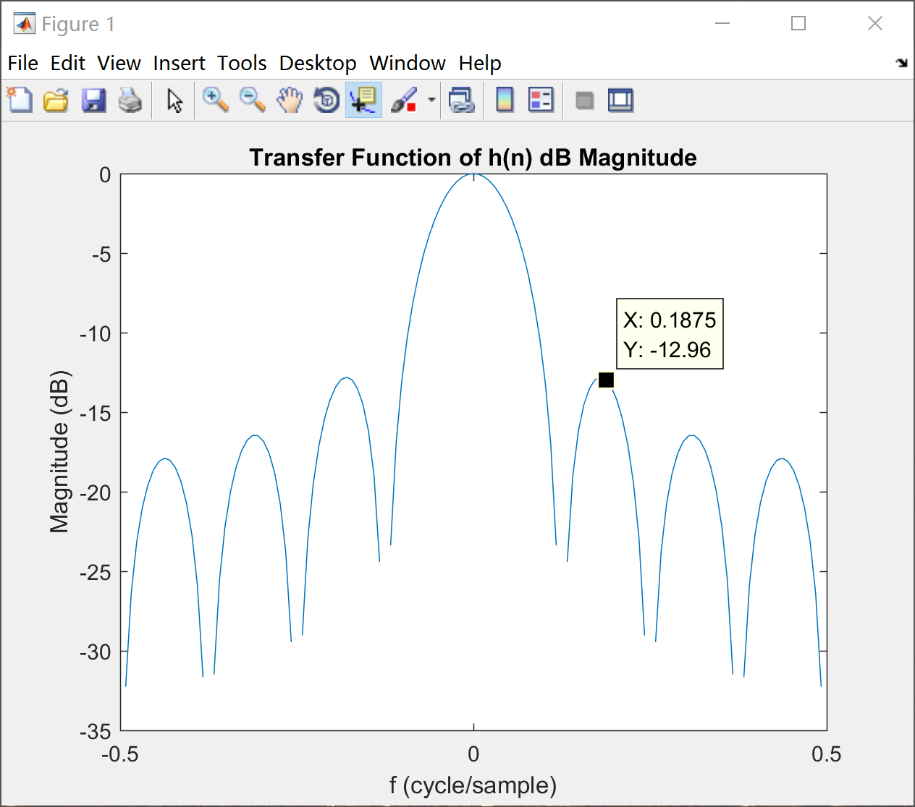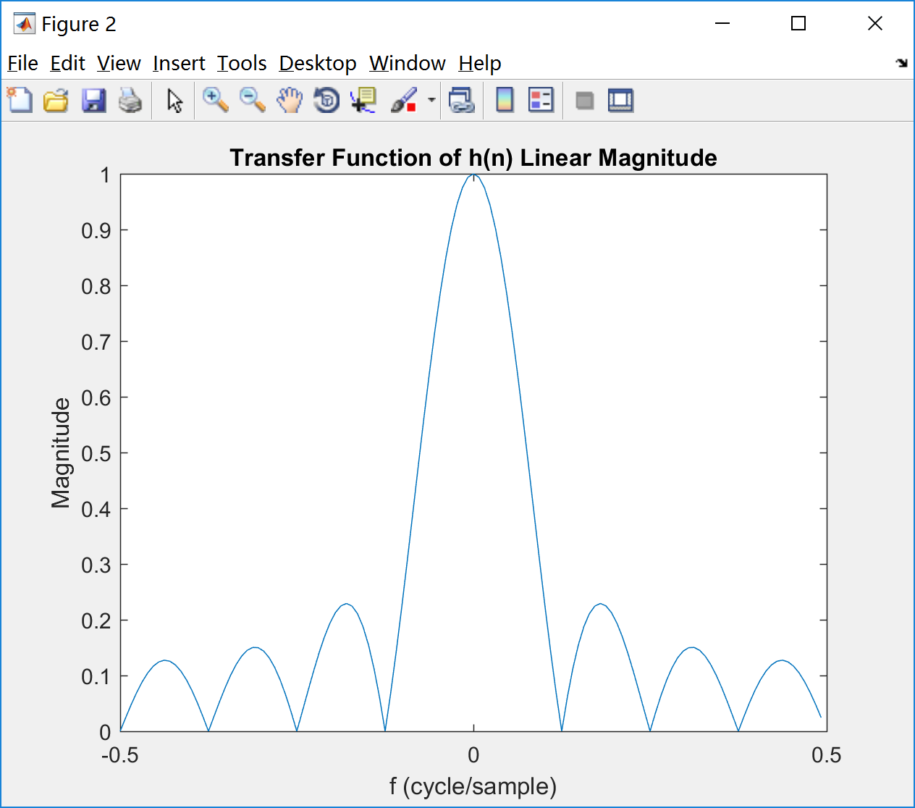

Fig. 1 Fig. 2

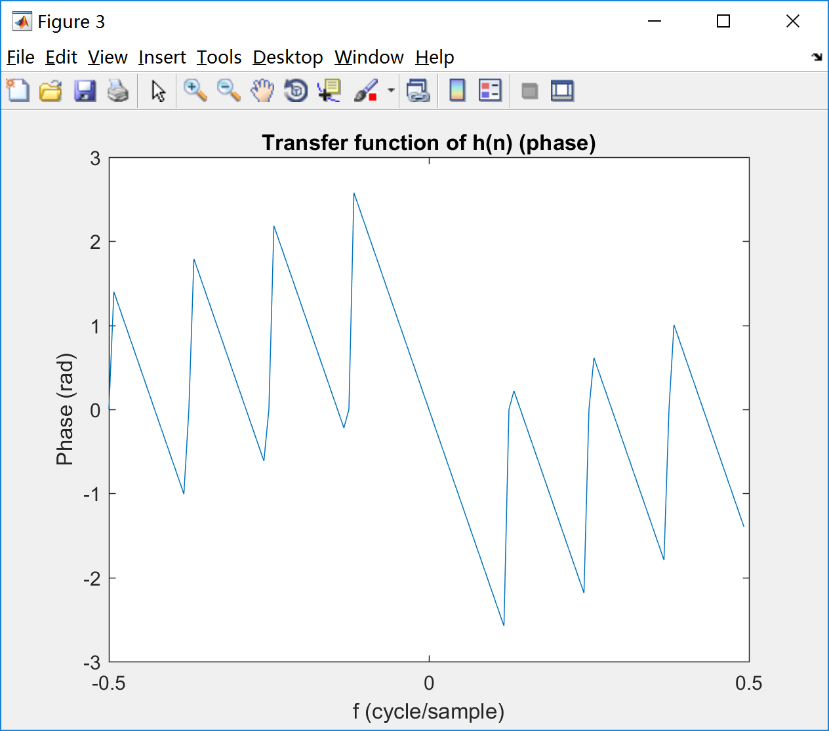

Fig. 3

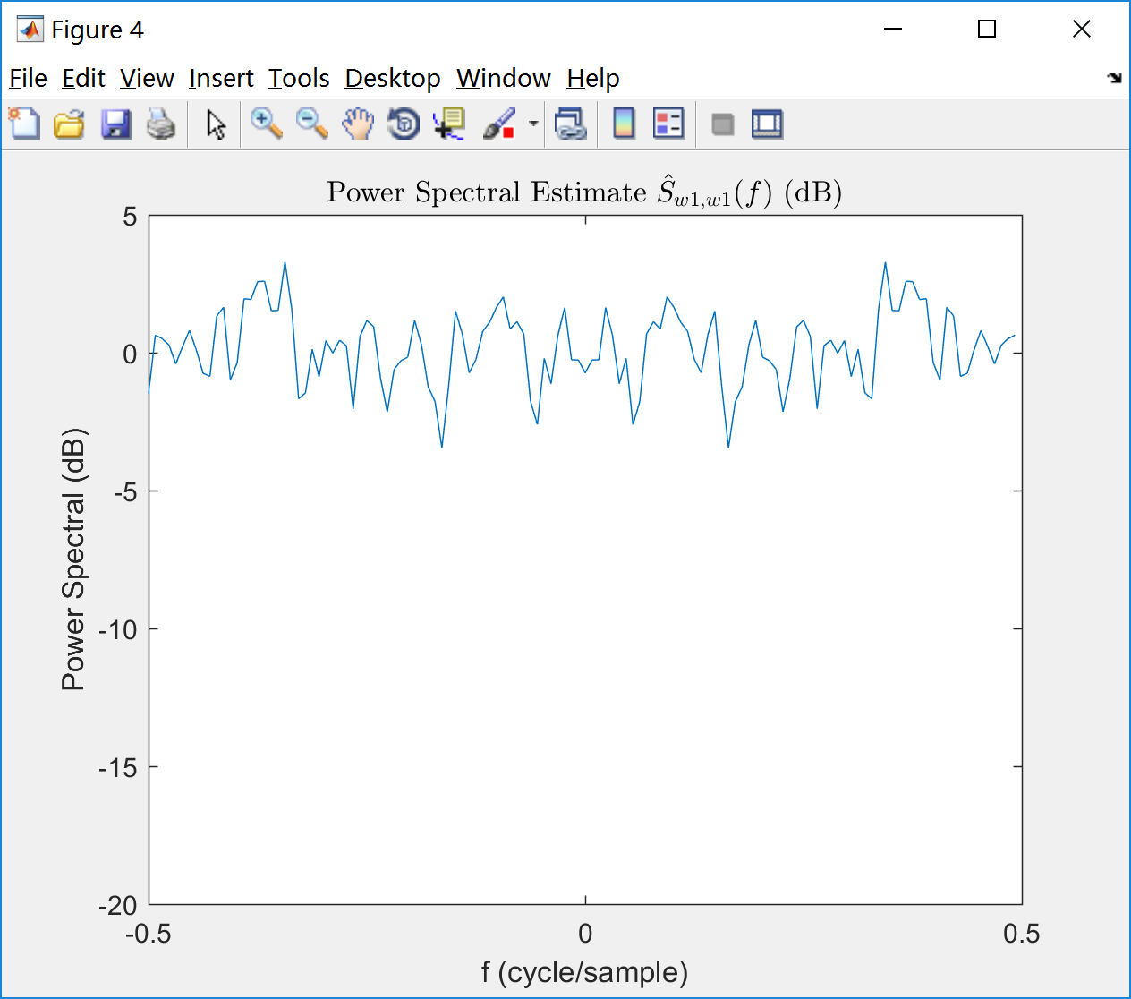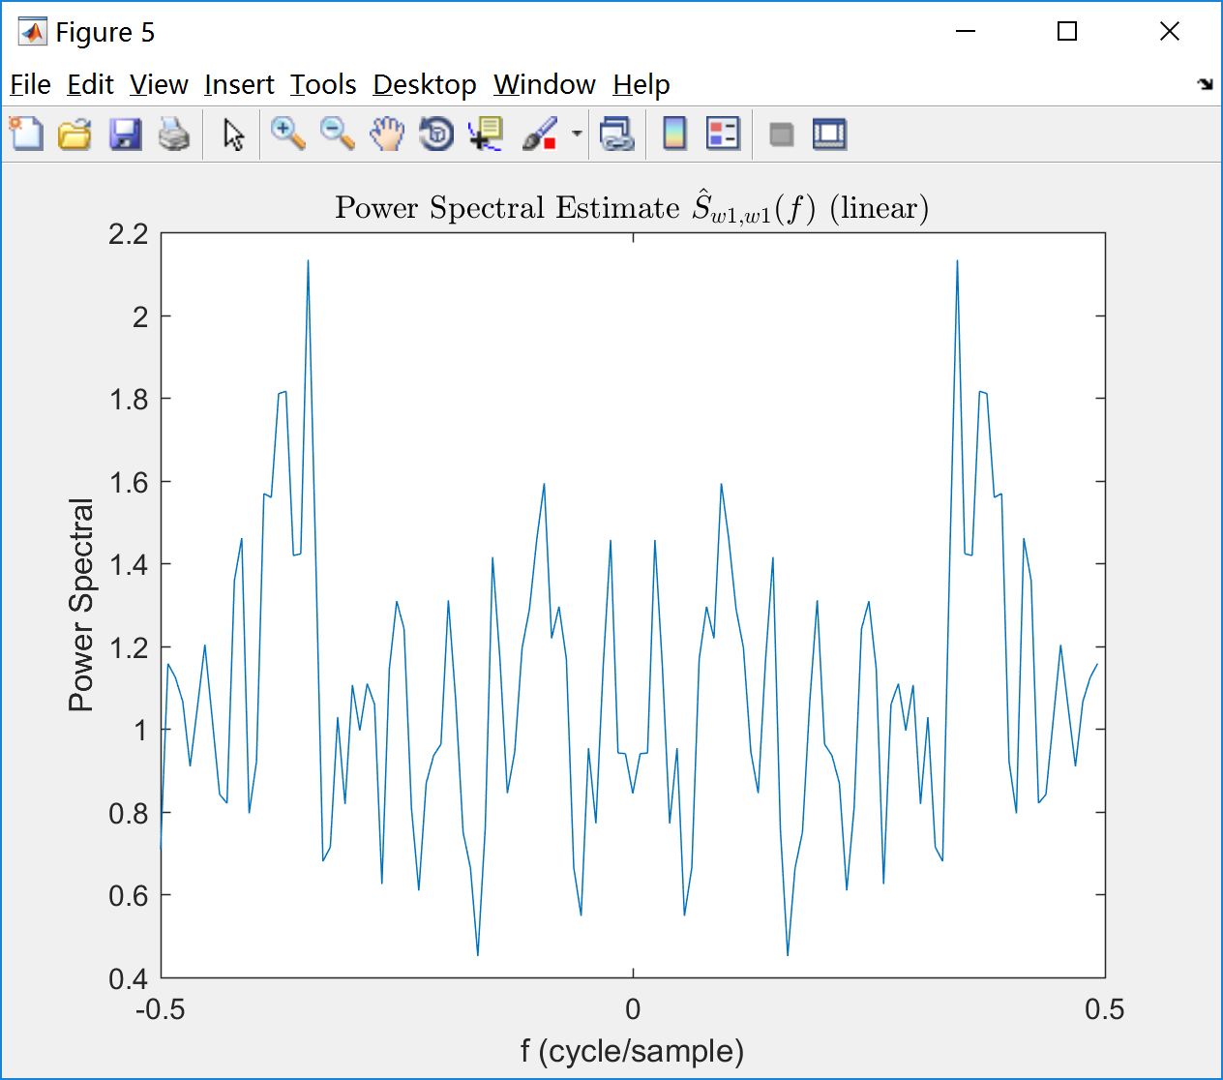

Fig. 4 Fig. 5

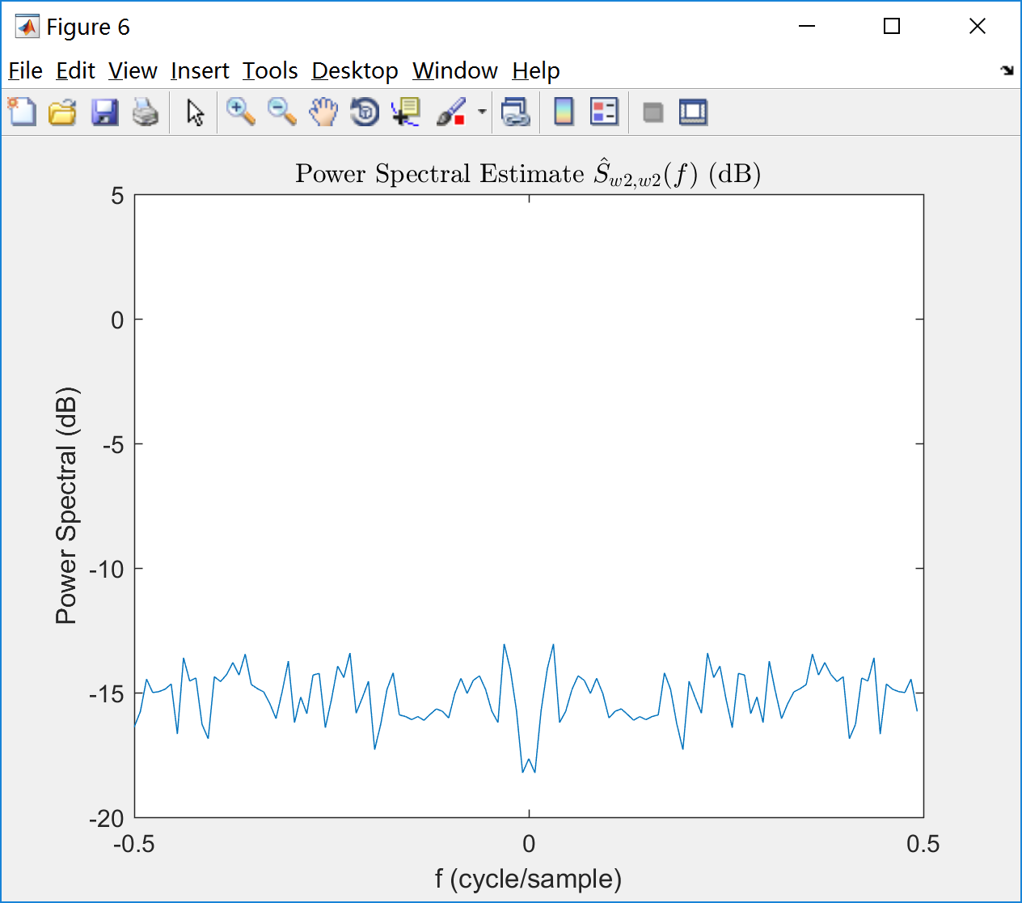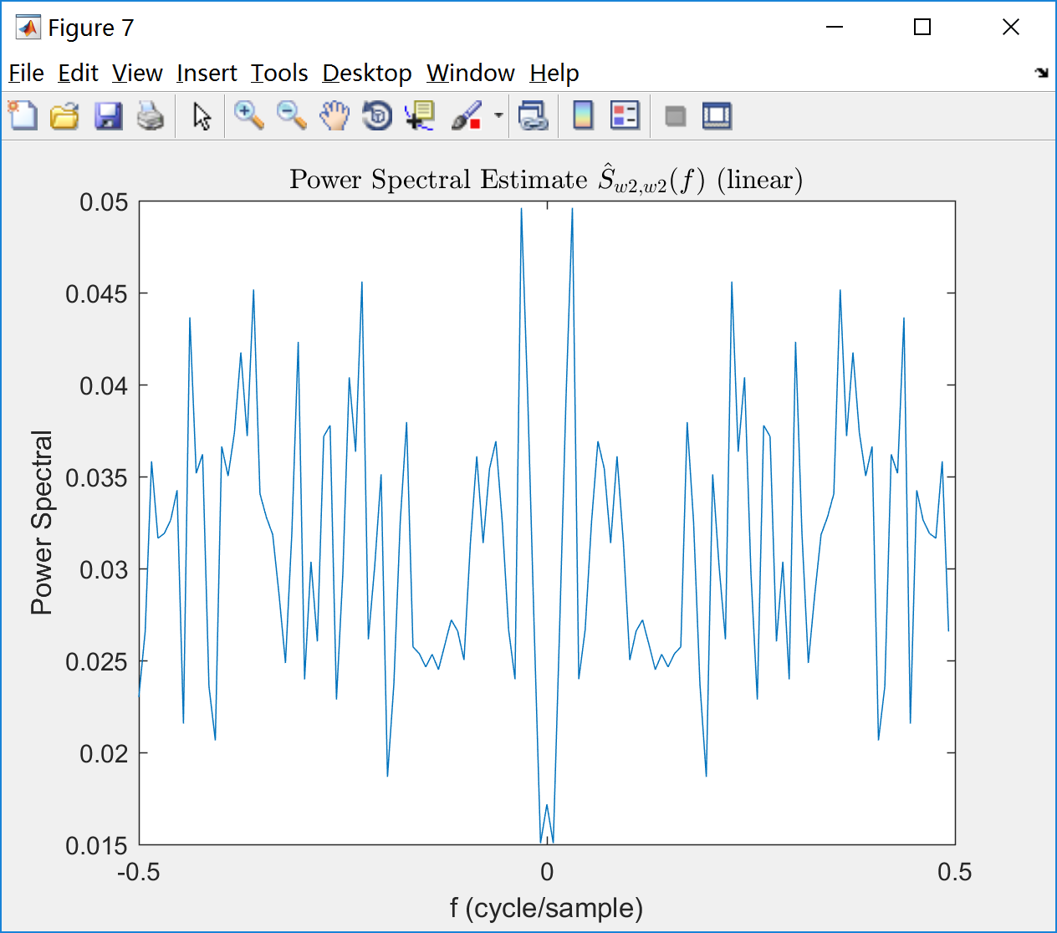

Fig. 6 Fig. 7

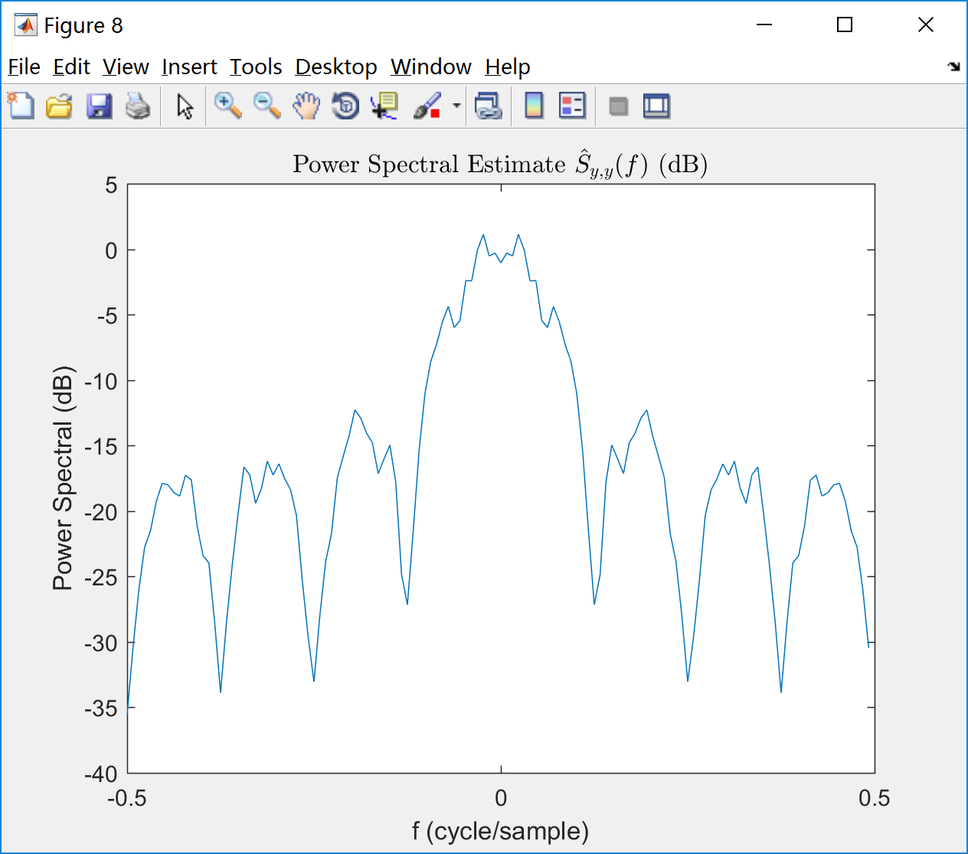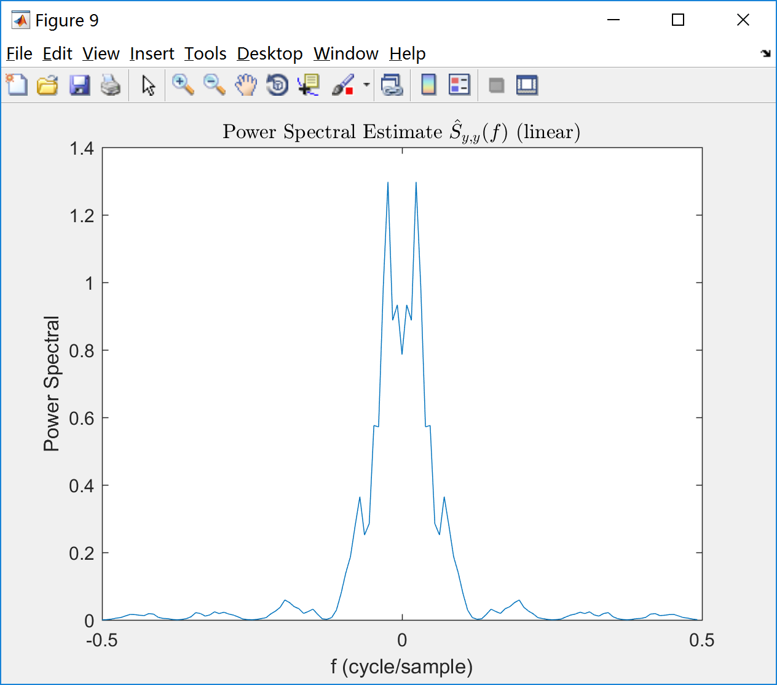

Fig. 8 Fig. 9

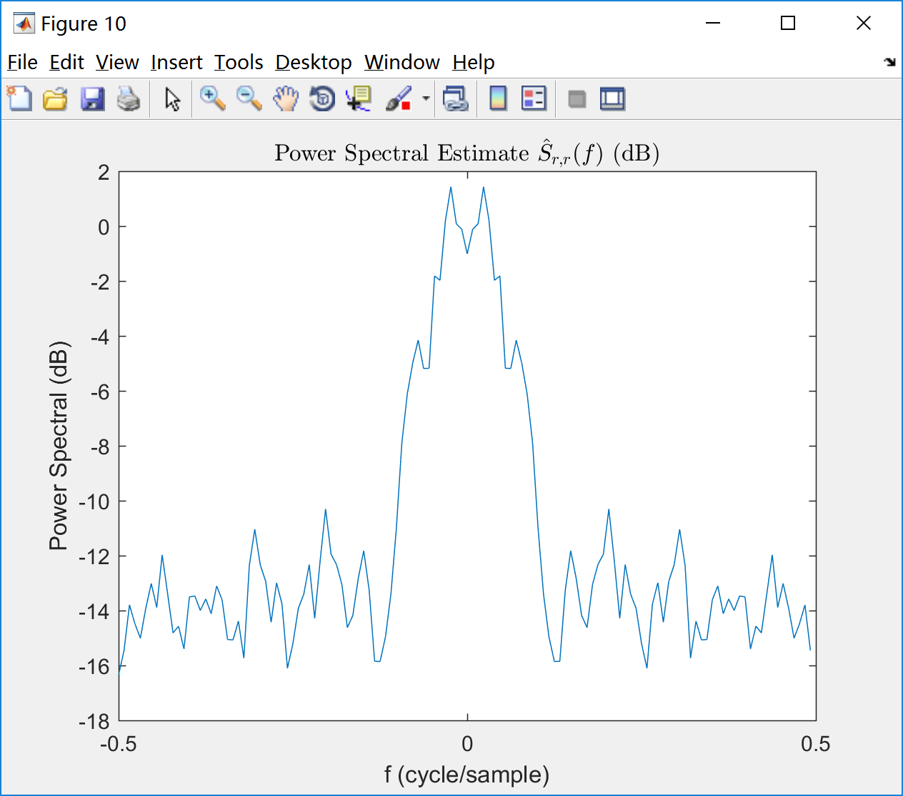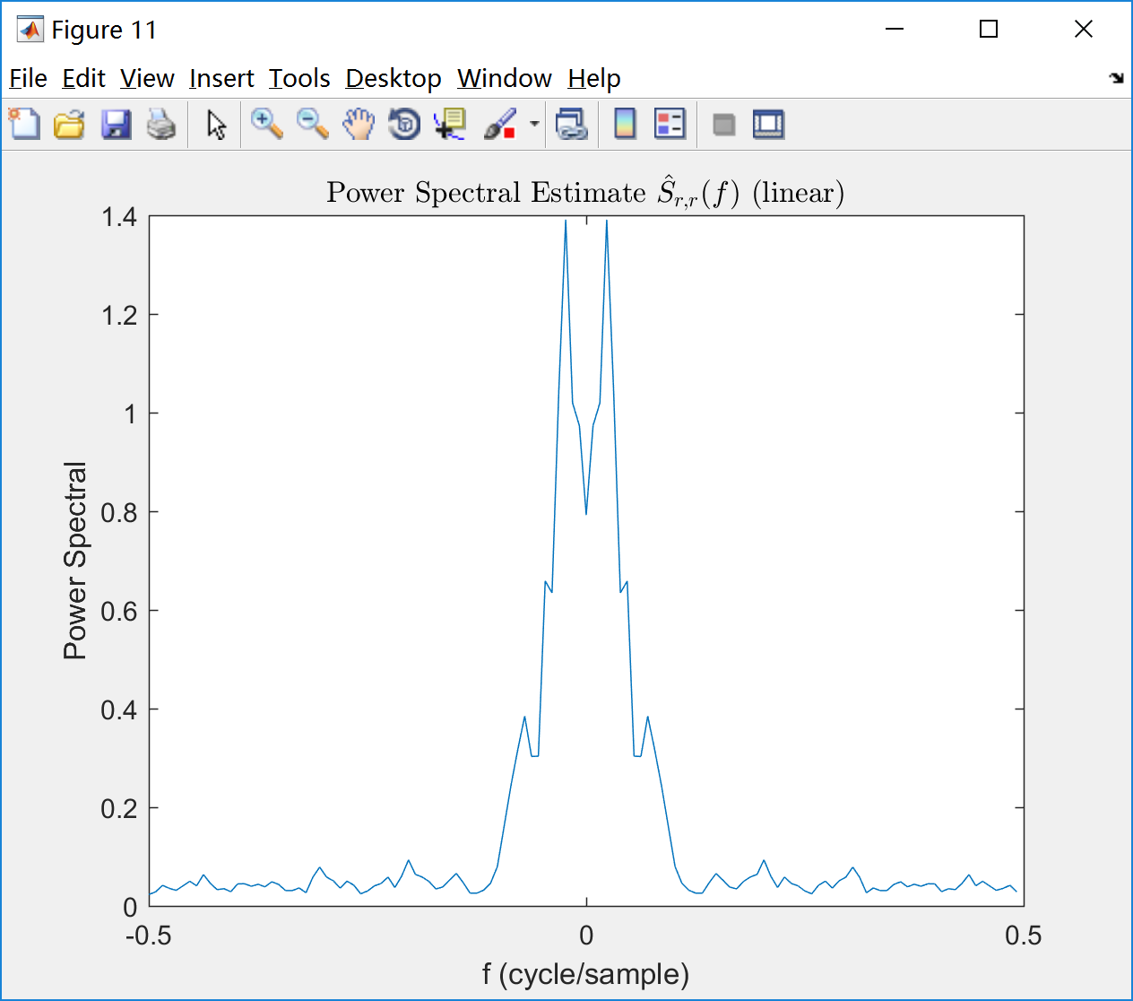

Fig. 10 Fig. 11

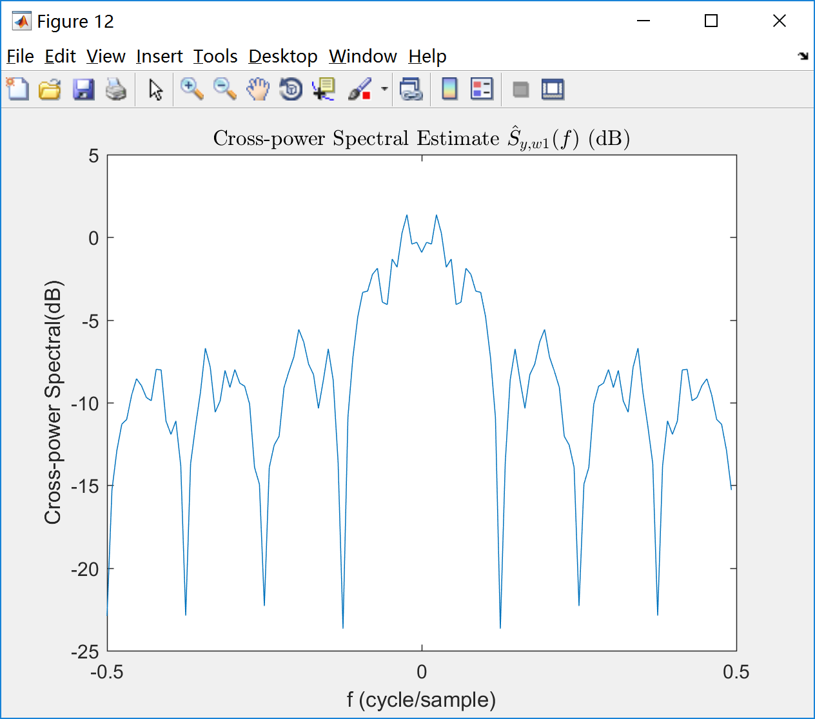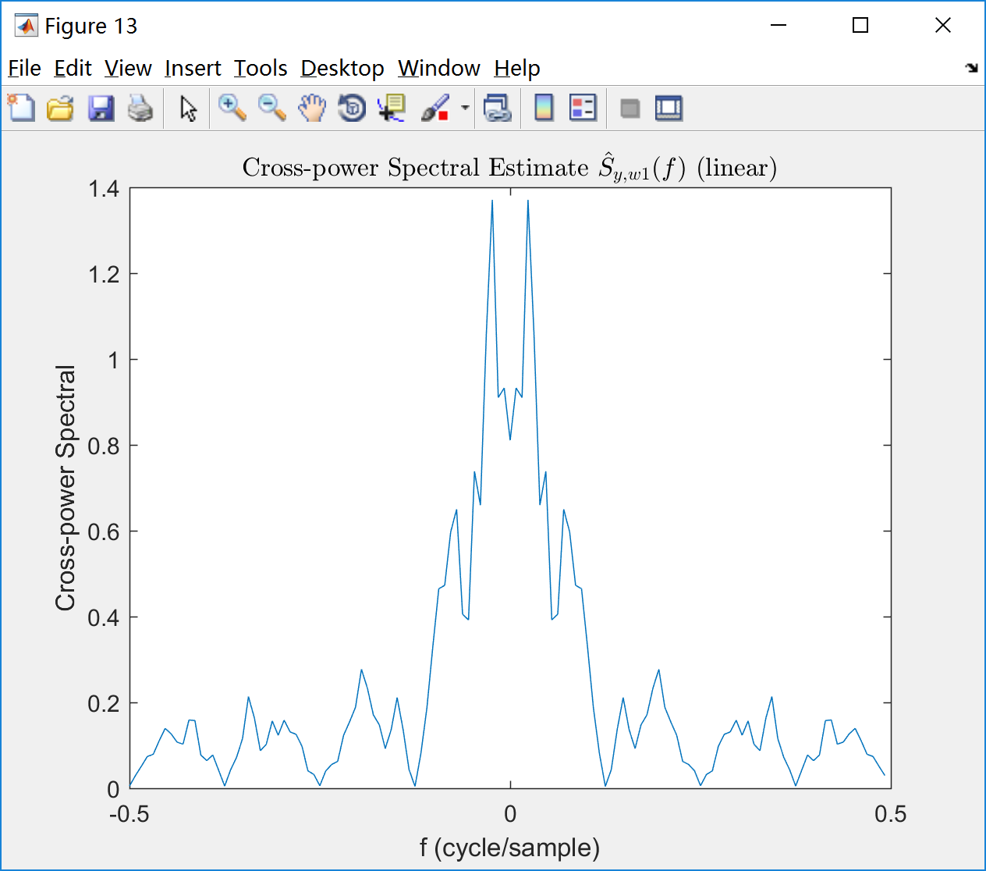

Fig. 12 Fig. 13

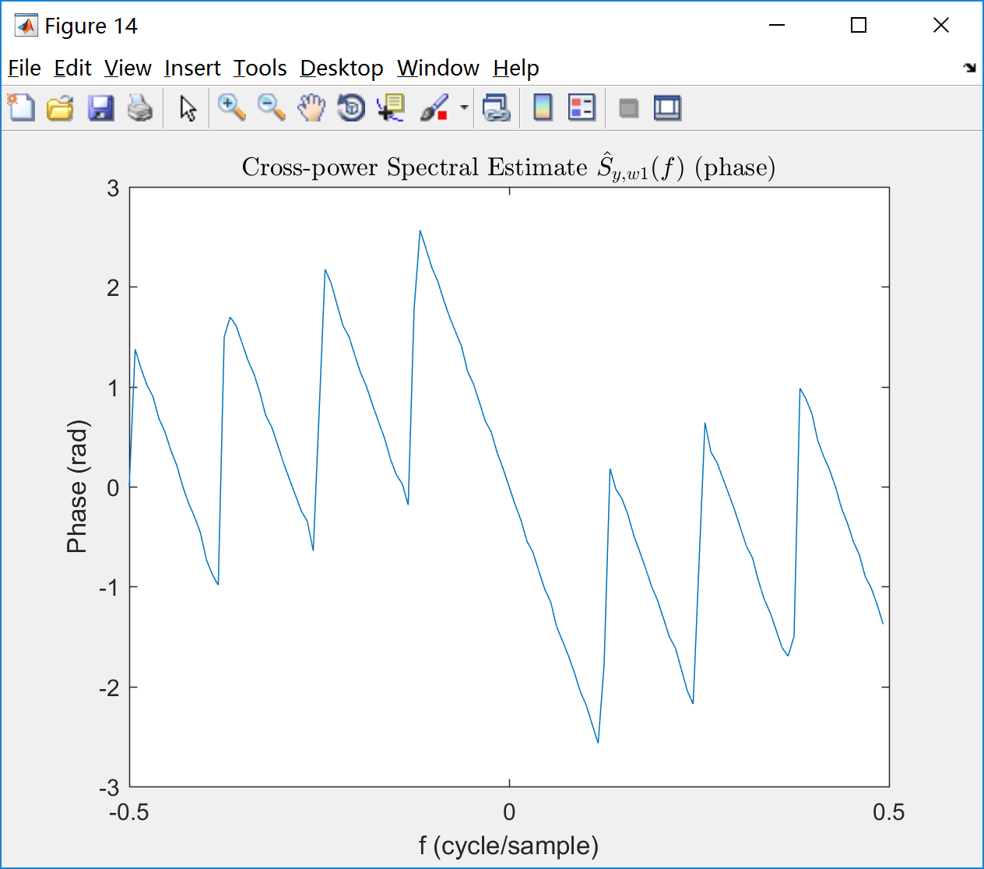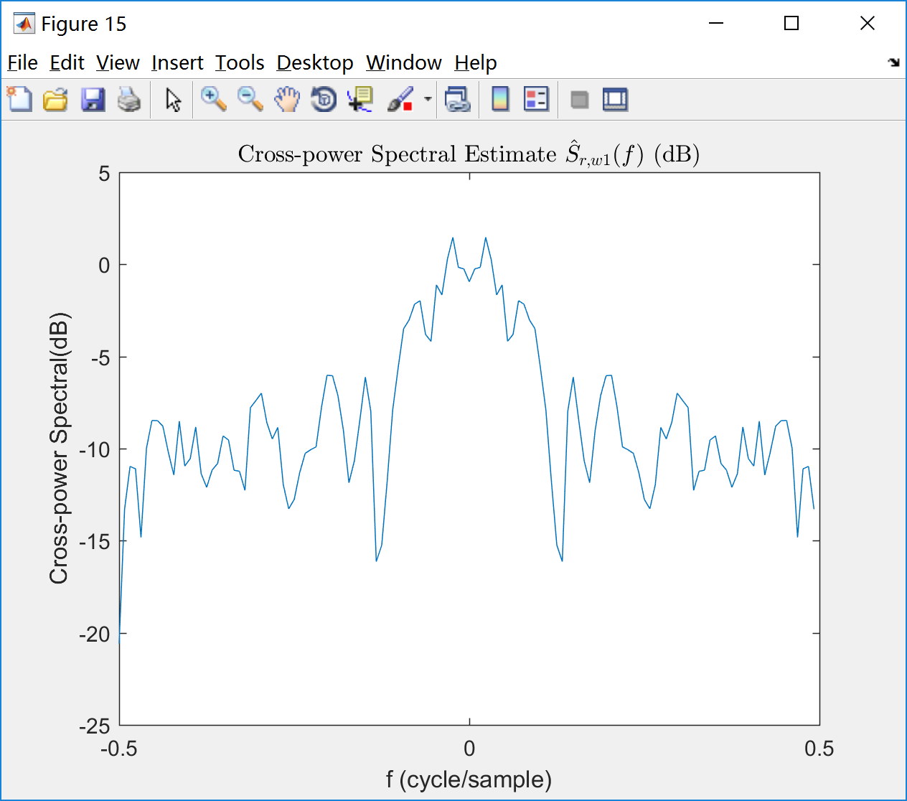

Fig. 14 Fig. 15

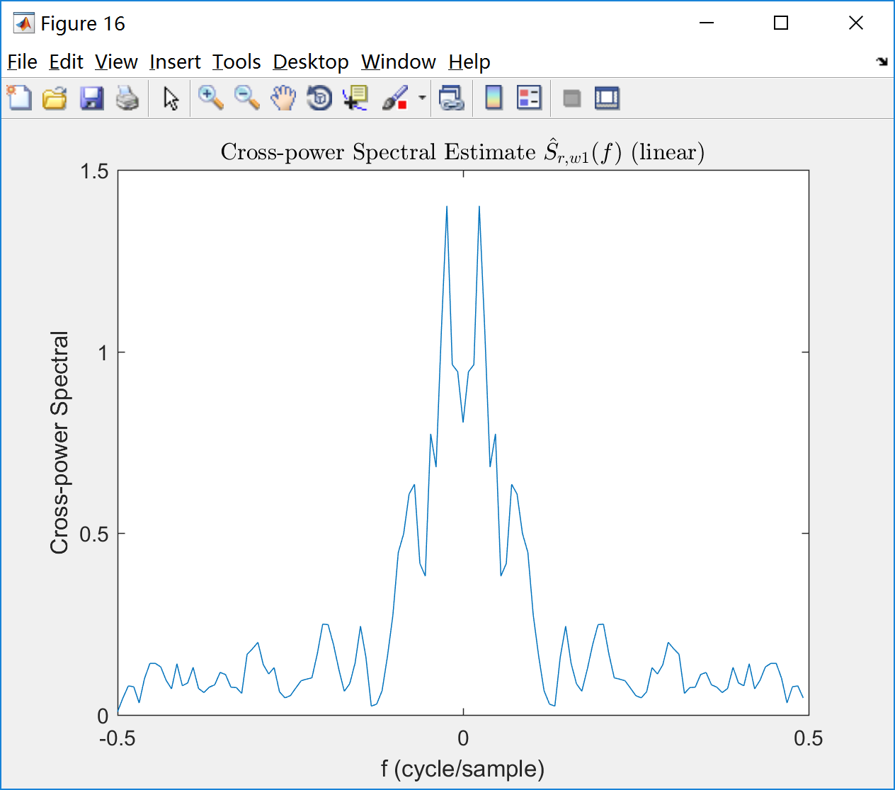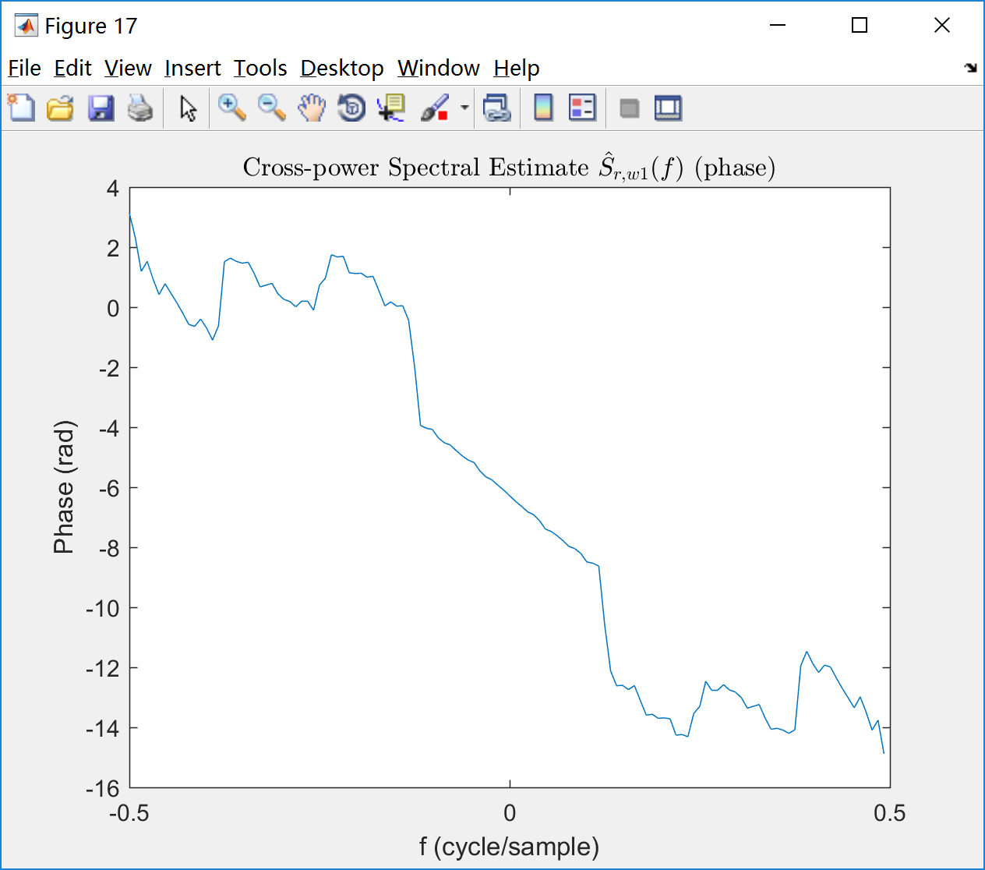

Fig. 16 Fig. 17

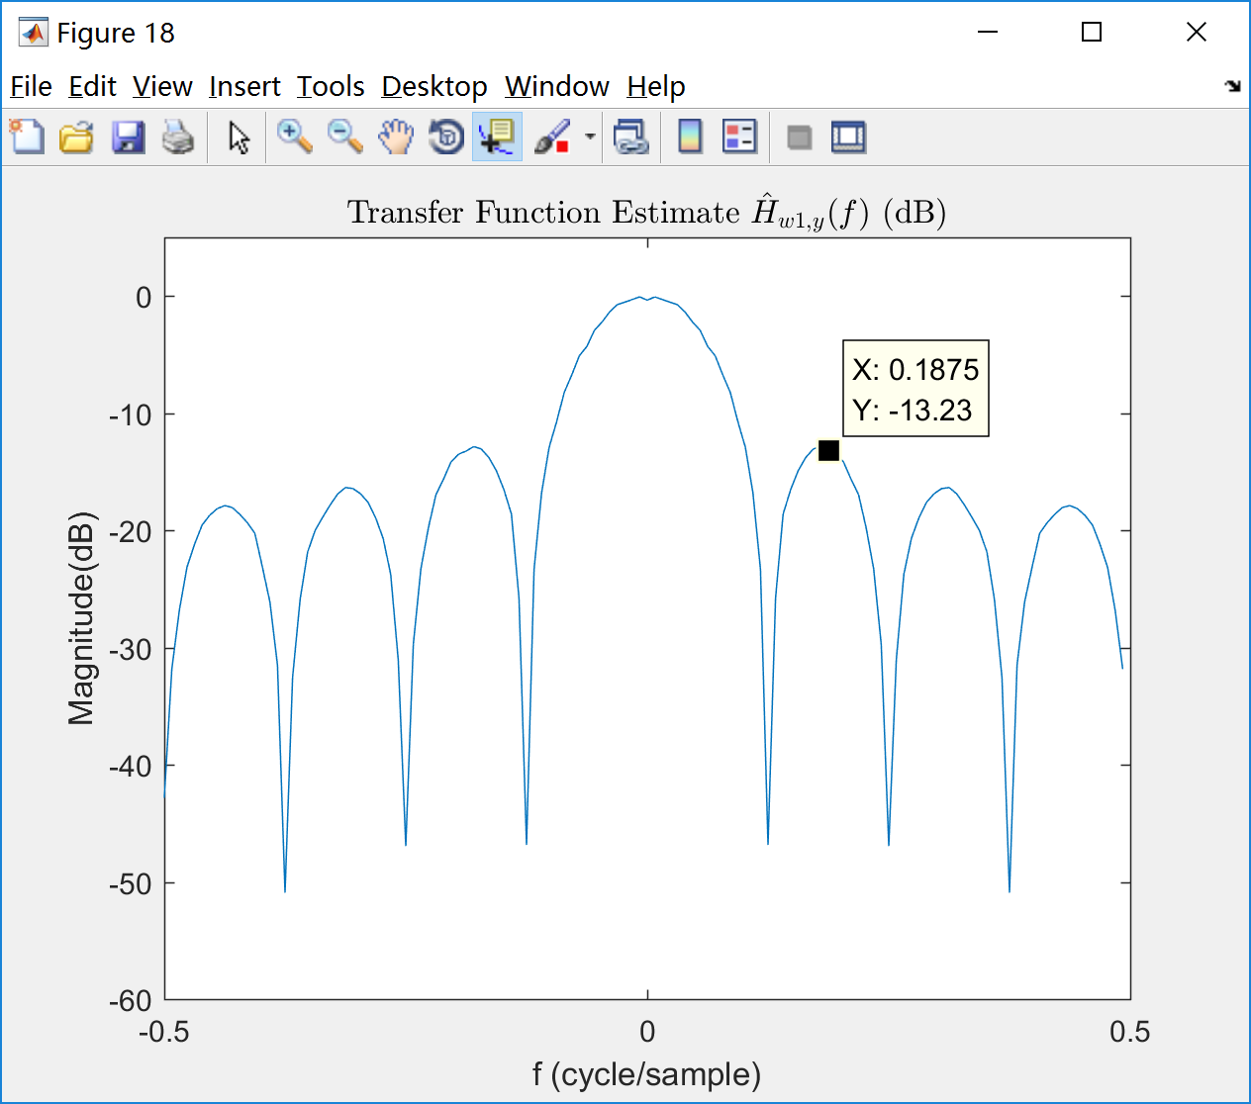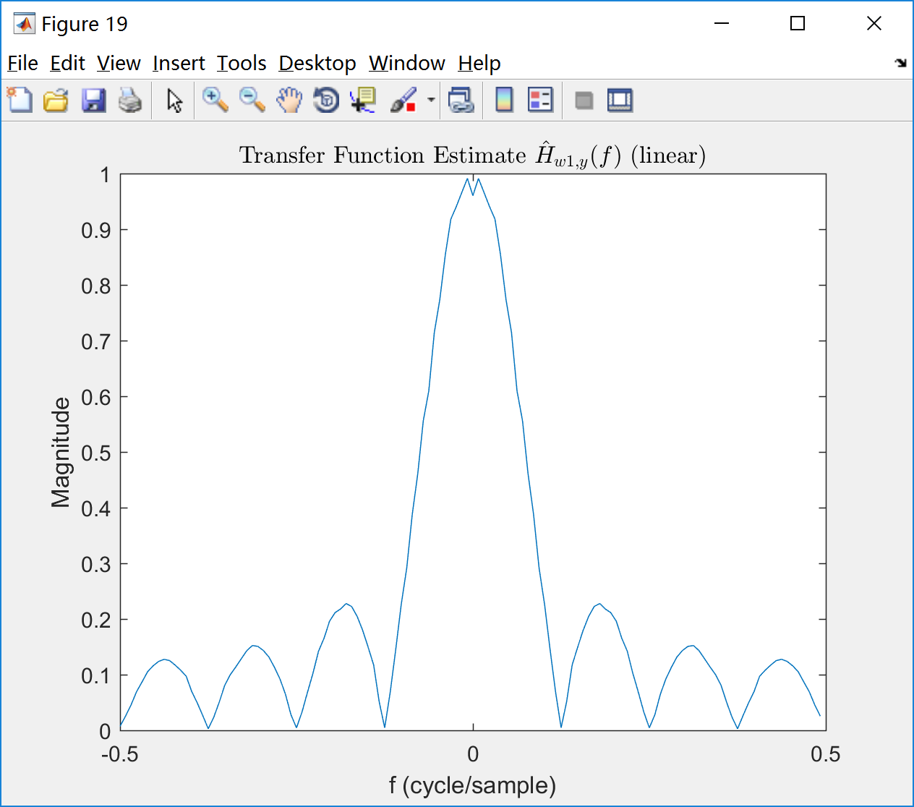

Fig. 18 Fig. 19

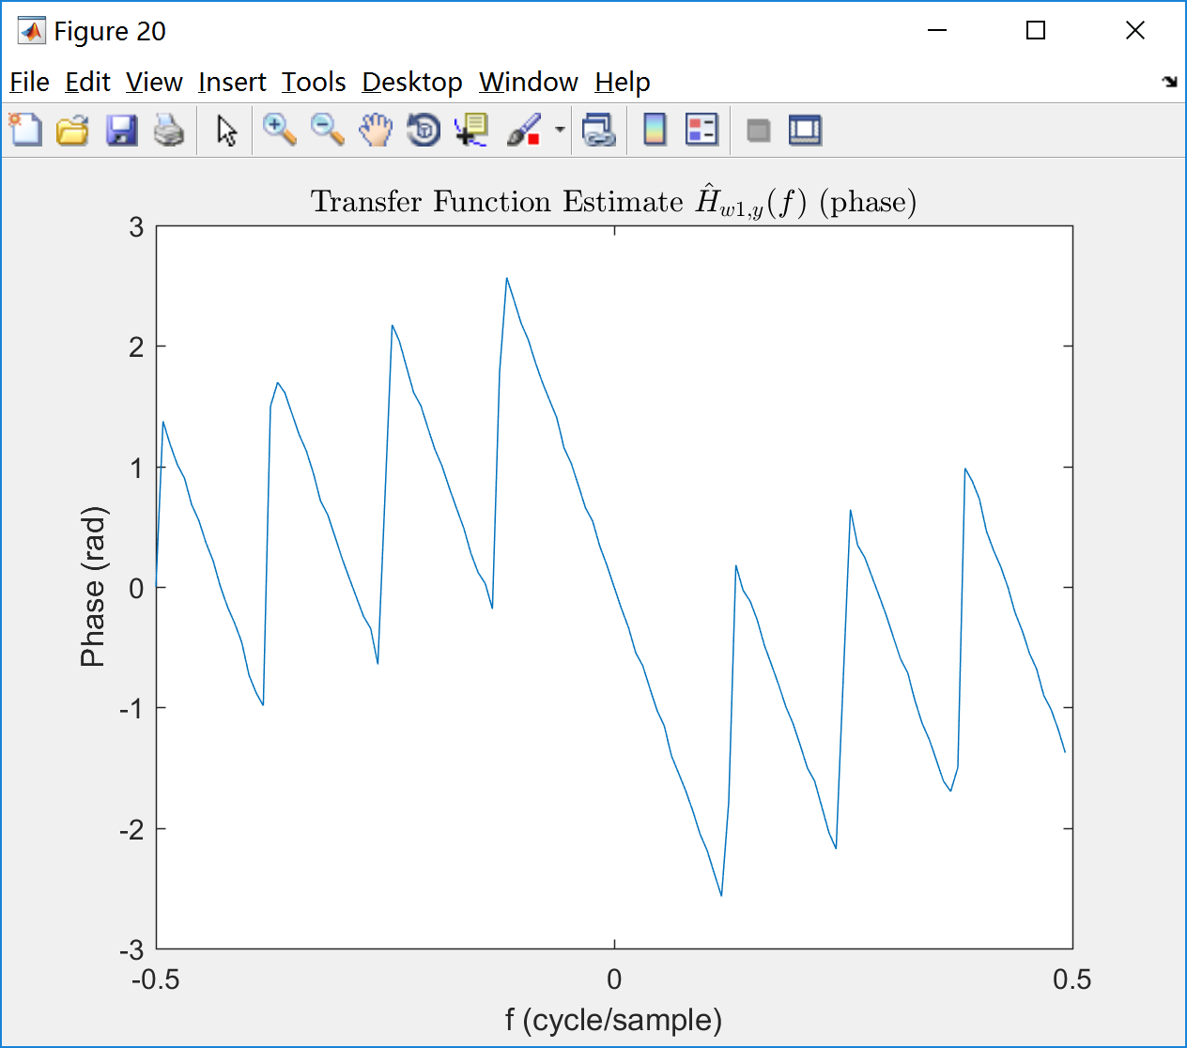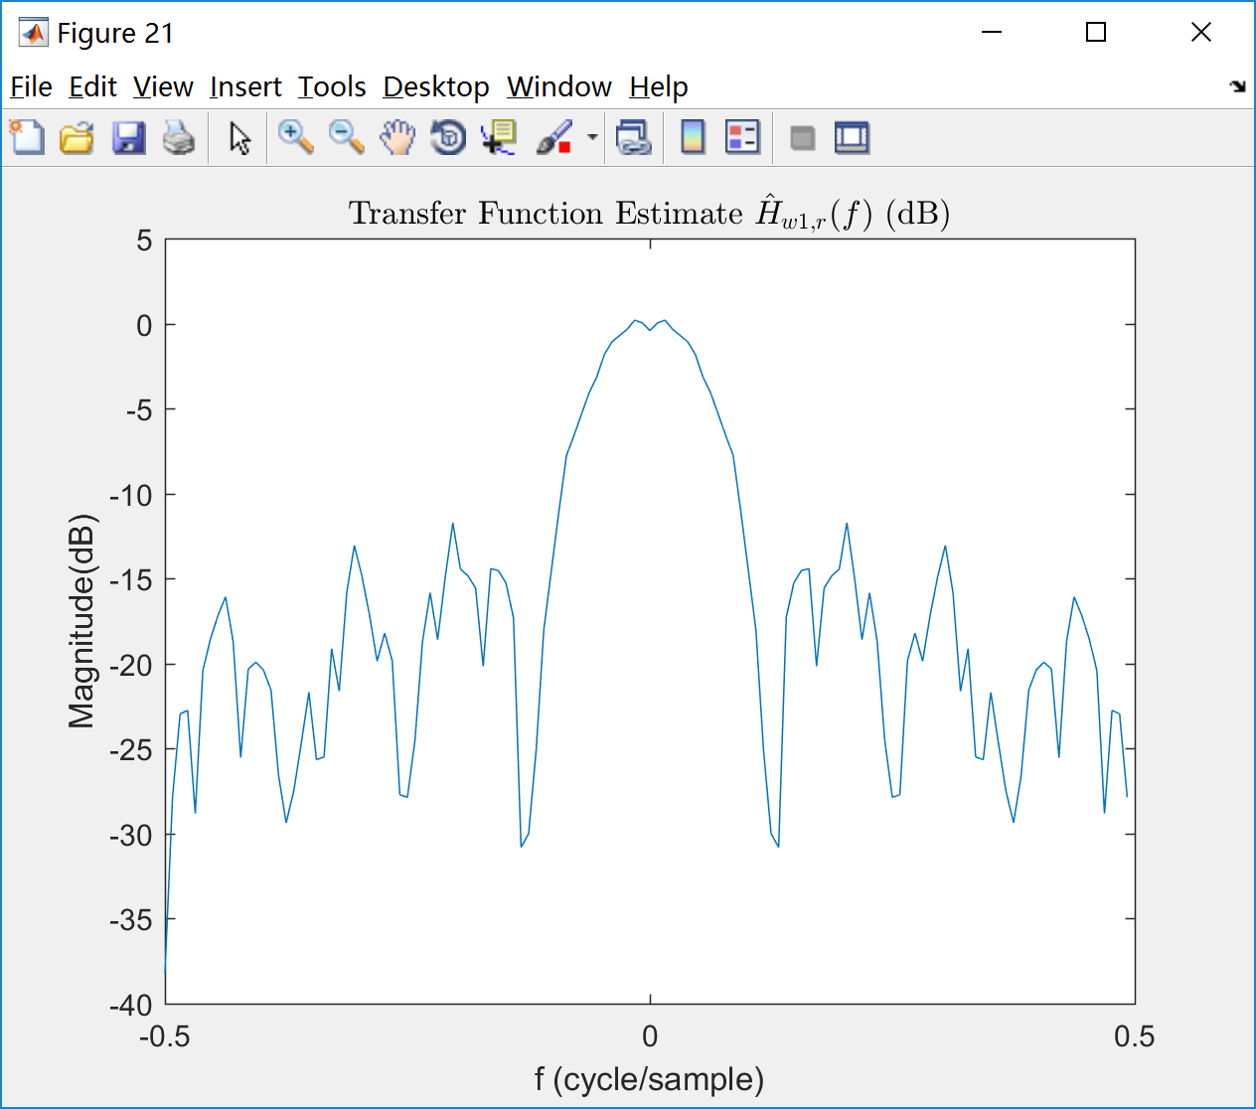

Fig. 20 Fig. 21

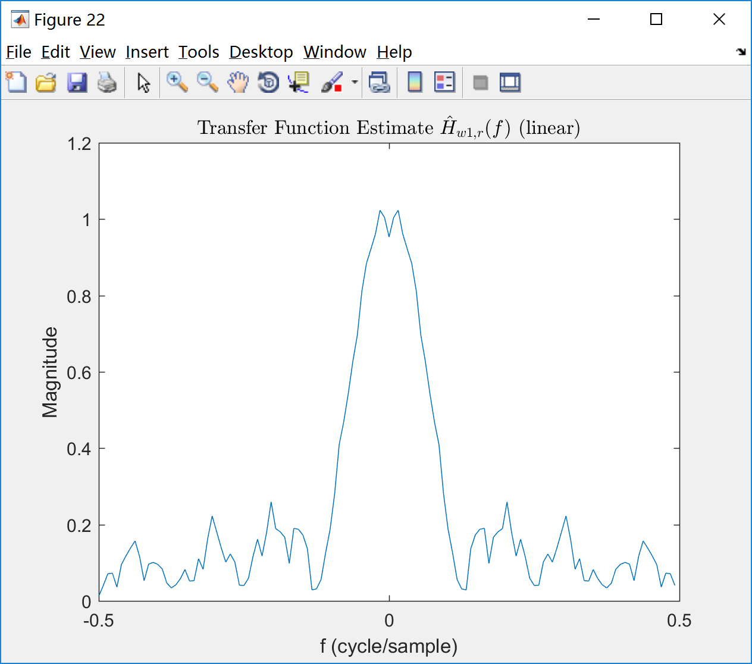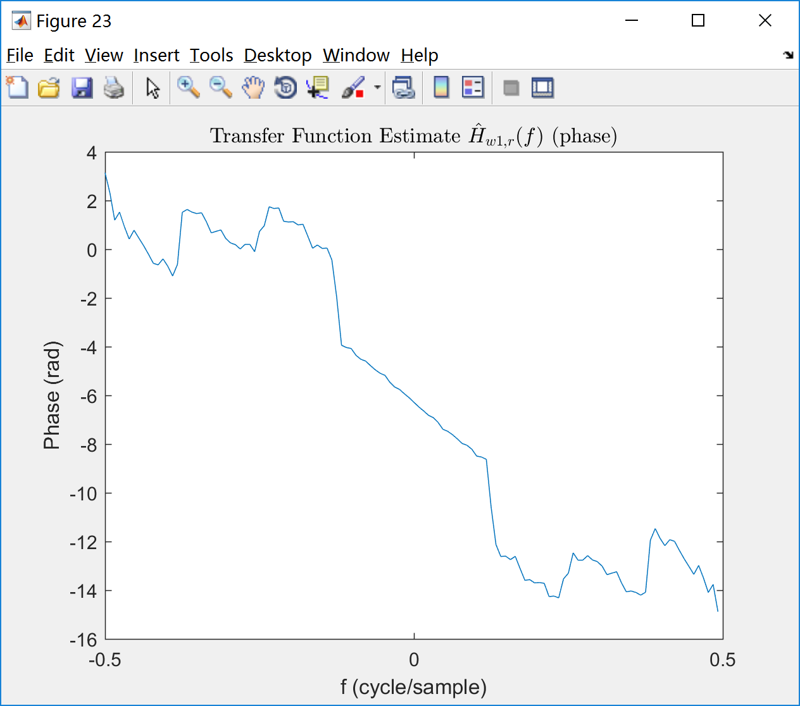

Fig. 22 Fig. 23

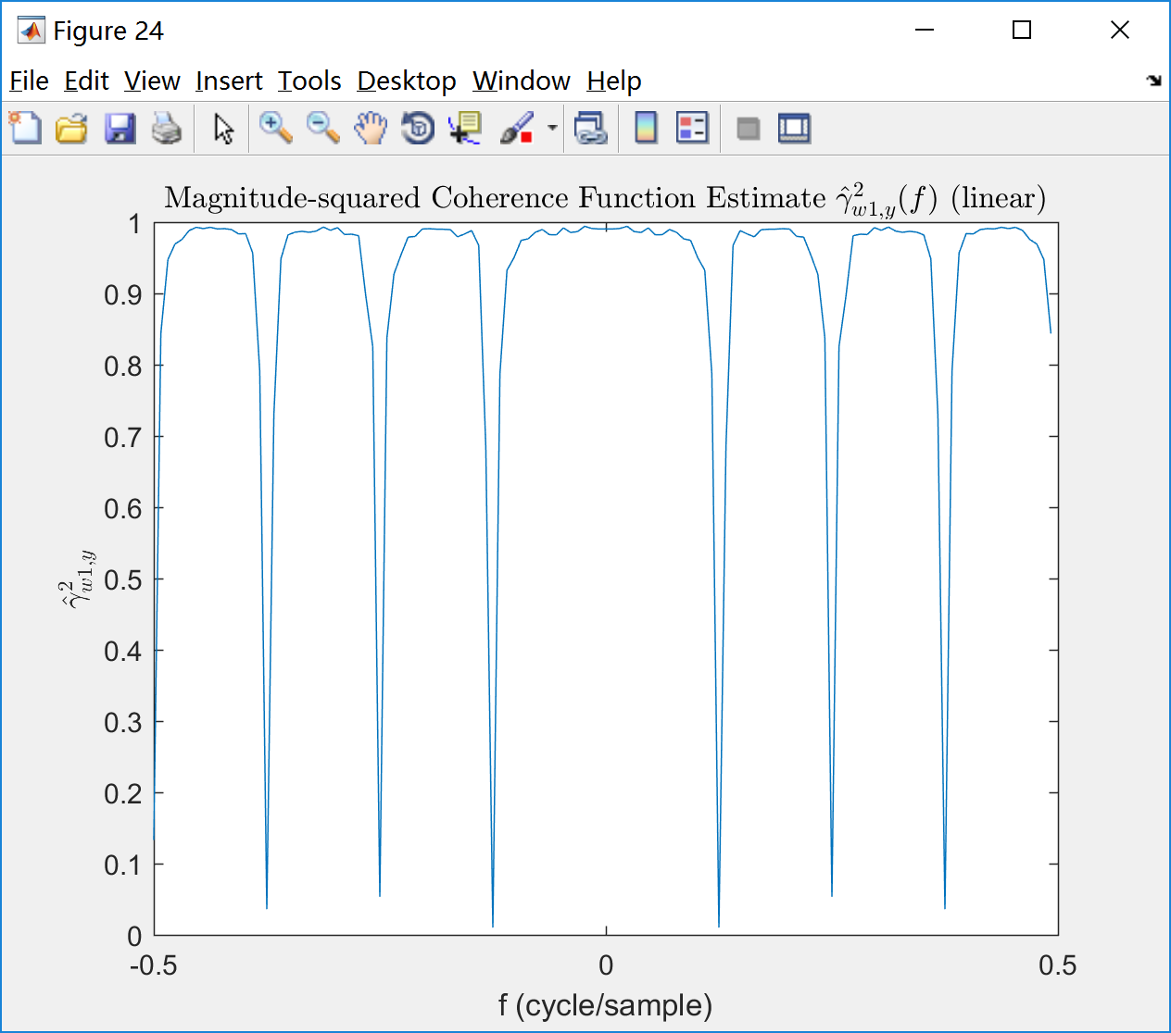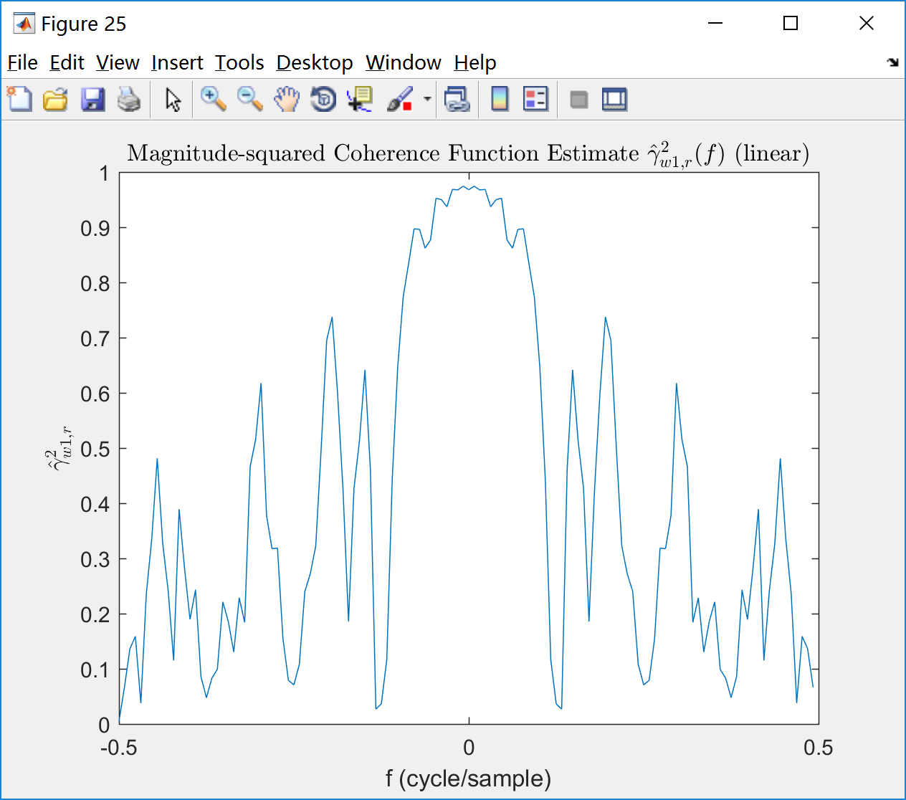

Fig. 24 Fig. 25

·Appendix

Script:

|  |
| --- |
| clc;clear;close all;  % Build signal  w1=randn(1,1024);  h=1/8*[1,1,1,1,1,1,1,1]; %%lowpass filter  y=filter(h,1,w1);  w2=randn(1,1024)/sqrt(32);  r=y+w2;  N=128;  %% A  H=fftshift(fft(h,N));  figure(1);  plot([-0.5:1/N:0.5-1/N],20*log10(abs(H)));  title('Transfer Function of h(n) dB Magnitude');  xlabel('f (cycle/sample)');ylabel('Magnitude (dB)');    figure(2);  plot([-0.5:1/N:0.5-1/N],abs(H));  title('Transfer Function of h(n) Linear Magnitude');  xlabel('f (cycle/sample)');ylabel('Magnitude');    figure(3);  plot([-0.5:1/N:0.5-1/N],unwrap(phase(H)));  title('Transfer function of h(n) (phase)');  xlabel('f (cycle/sample)');ylabel('Phase (rad)');  %% B  figure(4);  Sw1w1 = fftshift(pwelch(w1,128,64,128,1,'twosided','psd'));  plot([-0.5:1/N:0.5-1/N],10*log10(Sw1w1));  xlabel('f (cycle/sample)');ylabel('Power Spectral (dB)');  title('Power Spectral Estimate $\hat{S}_{w1,w1}(f)$ (dB)','Interpreter','latex');  axis([-0.5,0.5,-20,5]);    figure(5);  plot([-0.5:1/N:0.5-1/N],Sw1w1);  xlabel('f (cycle/sample)');ylabel('Power Spectral');  title('Power Spectral Estimate $\hat{S}_{w1,w1}(f)$ (linear)','Interpreter','latex');  figure(6);  Sw2w2= fftshift(pwelch(w2,128,64,128,1,'twosided','psd'));  plot([-0.5:1/N:0.5-1/N],10*log10(Sw2w2));  xlabel('f (cycle/sample)');ylabel('Power Spectral (dB)');  title('Power Spectral Estimate $\hat{S}_{w2,w2}(f)$ (dB)','Interpreter','latex');  axis([-0.5,0.5,-20,5]);    figure(7);  plot([-0.5:1/N:0.5-1/N],Sw2w2);  xlabel('f (cycle/sample)');ylabel('Power Spectral');  title('Power Spectral Estimate $\hat{S}_{w2,w2}(f)$ (linear)','Interpreter','latex');  figure(8);  Syy = fftshift(pwelch(y,128,64,128,1,'twosided','psd'));  plot([-0.5:1/N:0.5-1/N],10*log10(Syy));  xlabel('f (cycle/sample)');ylabel('Power Spectral (dB)');  title('Power Spectral Estimate $\hat{S}_{y,y}(f)$ (dB)','Interpreter','latex');    figure(9);  plot([-0.5:1/N:0.5-1/N],Syy);  xlabel('f (cycle/sample)');ylabel('Power Spectral');  title('Power Spectral Estimate $\hat{S}_{y,y}(f)$ (linear)','Interpreter','latex');    figure(10);  Srr = fftshift(pwelch(r,128,64,128,1,'twosided','psd'));  plot([-0.5:1/N:0.5-1/N],10*log10(Srr));  xlabel('f (cycle/sample)');ylabel('Power Spectral (dB)');  title('Power Spectral Estimate $\hat{S}_{r,r}(f)$ (dB)','Interpreter','latex');    figure(11);  plot([-0.5:1/N:0.5-1/N],Srr);  xlabel('f (cycle/sample)');ylabel('Power Spectral');  title('Power Spectral Estimate $\hat{S}_{r,r}(f)$ (linear)','Interpreter','latex');    %% C  figure(12);  Syw1=fftshift(cpsd(y,w1,128,64,128,1,'twosided'));  plot([-0.5:1/N:0.5-1/N],10*log10(abs(Syw1)));  xlabel('f (cycle/sample)');ylabel('Cross-power Spectral(dB)');  title('Cross-power Spectral Estimate $\hat{S}_{y,w1}(f)$ (dB)','Interpreter','latex');    figure(13);  plot([-0.5:1/N:0.5-1/N],abs(Syw1));  xlabel('f (cycle/sample)');ylabel('Cross-power Spectral');  title('Cross-power Spectral Estimate $\hat{S}_{y,w1}(f)$ (linear)','Interpreter','latex');    figure(14);  plot([-0.5:1/N:0.5-1/N],unwrap(phase(Syw1)));  title('Cross-power Spectral Estimate $\hat{S}_{y,w1}(f)$ (phase)','Interpreter','latex');  xlabel('f (cycle/sample)');ylabel('Phase (rad)');    figure(15);  Srw1=fftshift(cpsd(r,w1,128,64,128,1,'twosided'));  plot([-0.5:1/N:0.5-1/N],10*log10(abs(Srw1)));  xlabel('f (cycle/sample)');ylabel('Cross-power Spectral(dB)');  title('Cross-power Spectral Estimate $\hat{S}_{r,w1}(f)$ (dB)','Interpreter','latex');    figure(16);  plot([-0.5:1/N:0.5-1/N],abs(Srw1));  xlabel('f (cycle/sample)');ylabel('Cross-power Spectral');  title('Cross-power Spectral Estimate $\hat{S}_{r,w1}(f)$ (linear)','Interpreter','latex');    figure(17);  plot([-0.5:1/N:0.5-1/N],unwrap(phase(Srw1)));  title('Cross-power Spectral Estimate $\hat{S}_{r,w1}(f)$ (phase)','Interpreter','latex');  xlabel('f (cycle/sample)');ylabel('Phase (rad)');  %% D  figure(18);  Hw1y=Syw1./Sw1w1;  plot([-0.5:1/N:0.5-1/N],20*log10(abs(Hw1y)));  xlabel('f (cycle/sample)');ylabel('Magnitude(dB)');  title('Transfer Function Estimate $\hat{H}_{w1,y}(f)$ (dB)','Interpreter','latex');    figure(19);  plot([-0.5:1/N:0.5-1/N],abs(Hw1y));  xlabel('f (cycle/sample)');ylabel('Magnitude');  title('Transfer Function Estimate $\hat{H}_{w1,y}(f)$ (linear)','Interpreter','latex');    figure(20);  plot([-0.5:1/N:0.5-1/N],unwrap(phase(Hw1y)));  title('Transfer Function Estimate $\hat{H}_{w1,y}(f)$ (phase)','Interpreter','latex');  xlabel('f (cycle/sample)');ylabel('Phase (rad)');    figure(21);  Hw1r=Srw1./Sw1w1;  plot([-0.5:1/N:0.5-1/N],20*log10(abs(Hw1r)));  xlabel('f (cycle/sample)');ylabel('Magnitude(dB)');  title('Transfer Function Estimate $\hat{H}_{w1,r}(f)$ (dB)','Interpreter','latex');    figure(22);  plot([-0.5:1/N:0.5-1/N],abs(Hw1r));  xlabel('f (cycle/sample)');ylabel('Magnitude');  title('Transfer Function Estimate $\hat{H}_{w1,r}(f)$ (linear)','Interpreter','latex');    figure(23);  plot([-0.5:1/N:0.5-1/N],unwrap(phase(Hw1r)));  title('Transfer Function Estimate $\hat{H}_{w1,r}(f)$ (phase)','Interpreter','latex');  xlabel('f (cycle/sample)');ylabel('Phase (rad)');  %% E  figure(24);  gamma_w1y=abs(Syw1).^2./Syy./Sw1w1;  plot([-0.5:1/N:0.5-1/N],abs(gamma_w1y));  xlabel('f (cycle/sample)');ylabel('$\hat{\gamma}_{w1,y}^{2}$','Interpreter','latex');  title('Magnitude-squared Coherence Function Estimate $\hat{\gamma}_{w1,y}^{2}(f)$ (linear)','Interpreter','latex');    figure(25);  gamma_w1r=abs(Srw1).^2./Srr./Sw1w1;  plot([-0.5:1/N:0.5-1/N],abs(gamma_w1r));  xlabel('f (cycle/sample)');ylabel('$\hat{\gamma}_{w1,r}^{2}$','Interpreter','latex');  title('Magnitude-squared Coherence Function Estimate $\hat{\gamma}_{w1,r}^{2}(f)$ (linear)','Interpreter','latex'); |